Categorilla – Golf Courses
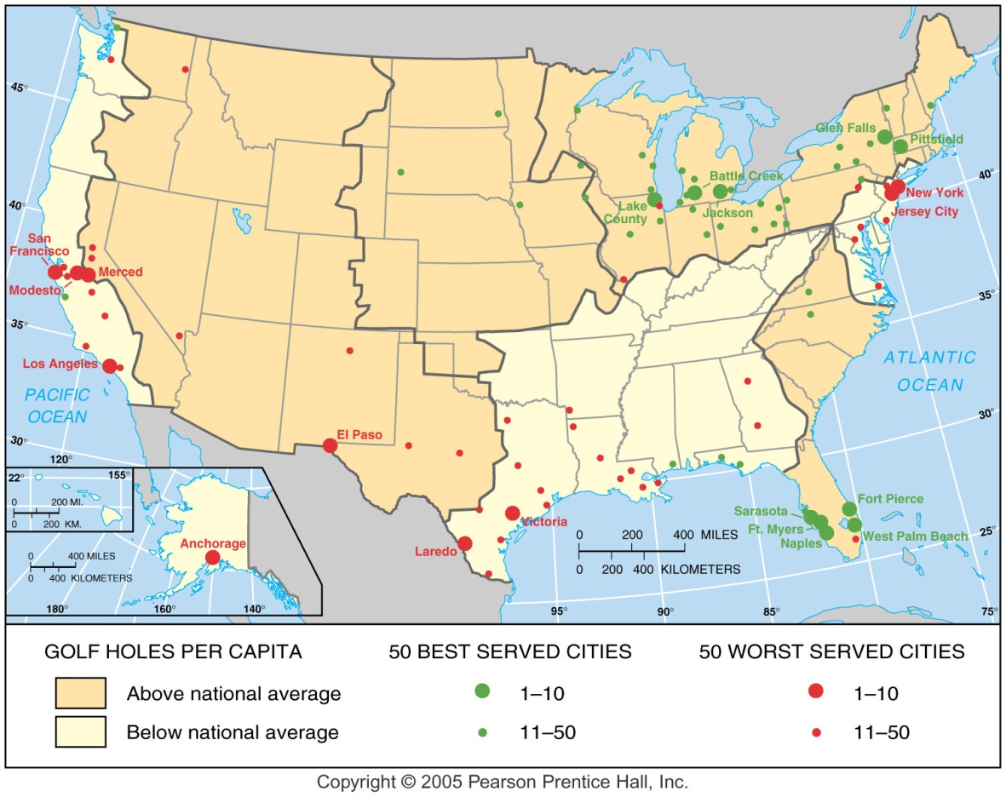
Golf Courses, because of their large size (200 acres), provide a prominent example of imposing popular culture on the environment. A surge in U.S. golf popularity has spawned construction of roughly 200 courses during the past two decades. Geographer John Rooneyattributes this to increased income and leisure time, especially among recently retired older people and younger people with flexible working hours.
John Rooney identified the 50 best-served and worst-served metropolitan areas in terms of the number of golf holes per capita.

Name the top 10 cities:

Name the worst 10 cities:

