Name: Date: Per:
Categorilla – English-Speaking Countries
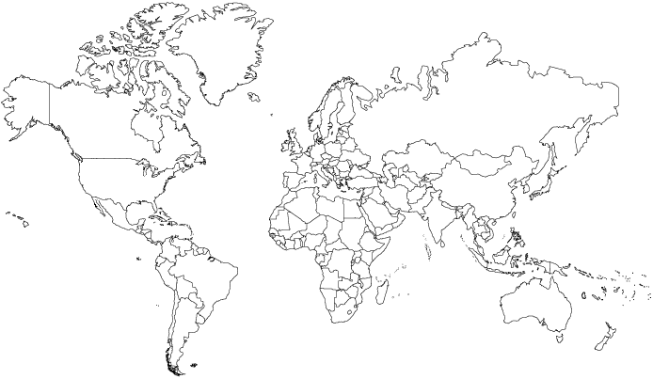

.
English is an official language in 57 countries. English is also the predominant language in the United States and Australia, although neither country has declared it to be the official language. Pick any color and fill in these English speaking countries in.

- Antigua & Barbuda
- Australia
- Bahamas
- Barbados
- Belize
- Botswana
- Brunei
- Cameroon
- Canada
- Dominica
- Ethiopia
- Fiji
- Gambia
- Ghana
- Guyana
- India
- Ireland
- Israel
- Jamaica
- Kenya
- Kiribati
- Lesotho
- Liberia
- Madagascar
- Malawi
- Malta
- Marshall Island
- Mauritius
- Micronesia
- Namibia
- Nauru
- New Zealand
- Nigeria
- Pakistan
- Palau
- Papua New Guinea
- Philippines
- Samoa
- Sierra Leone
- Singapore
- Solomon Island
- South Africa
- St. Kitts & Nevis
- St. Lucia
- St. Vincent & The Grenadines
- Sudan
- Swaziland
- Tanzania
- Tonga
- Trinidad & Tobago
- Tuvalu
- Uganda
- United Kingdom
- United States of America
- Vanuatu
- Zambia
- Zimbabwe

