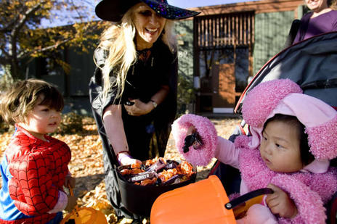
From festival to phenomenon:
The evolution of Halloween in pop culture
Despite its growth, the meaning of Halloween and how to celebrate it remain unsolved, experts say. Some Christian groups oppose the holiday because of its darker traditions, while others see the holiday as more of a secular celebration, with treats and costumes and communal fun.
Liz Martin, Deseret Morning News
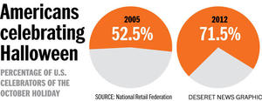
Summary
The old celebration of appreciation for the harvest and forthcoming winter has gradually been lost as Halloween has become a pop-culture phenomenon.

By Herb Scribner, Deseret News
Published: Thursday, Oct. 31 2013 6:00 a.m. MDT

The old celebration of appreciation for the harvest and forthcoming winter has gradually been lost as Halloween has become a pop-culture phenomenon.

Some Pennsylvania elementary schools aren't playing any tricks when it comes to Halloween this year.

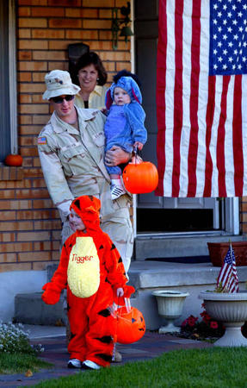
Within the past two weeks, schools throughout the Keystone State sent letters to parents announcing that Halloween festivities, such as costume parades, would be canceled due to the religious overtones of the holiday, reports said.

But one of the schools that canceled Halloween — Inglewood Elementary School in Montgomery County, which is just north of Philadelphia — has been given notice by its district, the North Penn School District, to host Halloween festivities.

The controversy comes at a time when Halloween is more popular than ever. Not only has spending on the holiday increased by 50 percent since 2005, according to the National Retail Foundation, but the number of people who dress up, trick or treat, or celebrate in some way has grown from about half of all Americans in 2005 to a whopping 71.5 percent last year.

Despite the controversy in Pennsylvania, Jeff Kinley, an author and religious scholar, said the holiday has little or nothing to do with what it once was — a celebration for the fall harvest and the coming winter. In its early years, Halloween was sometimes associated with dark magic, but these days, Kinley said, it's mostly about dressing up and eating candy.

“It’s become a mainstream thing,” Kinley said. “So, the religious undertones, they’re ... very historically in the past.” Halloween’s haunted past

Tammaye McDuff, a freelance religion editor based in Los Angeles, said many forget what Halloween was originally about. “It lost its meaning over the years,” she said.

Halloween’s roots stem from the Celtic holiday Samhain (pronounced "sah-win" or "sow-in") and the Welsh holiday Calan Gaeaf (pronounced kah-lan gah-eef), which trace back to, at the earliest, the 10th century and are still celebrated today. Both celebrations can include bonfires, dancing and honoring the dead.

Samhain, Calan Gaeaf and All Saints Day for Christians are all holidays celebrated at the end of October and the beginning of November that were early editions of the modern-day Halloween. While All Saints Day honors those who Christians believe have transcended to heaven, both Samhain and Calan Gaeaf celebrate the forthcoming winter.

Scotland had its own brand of celebration for Halloween as the years moved forward. Children would blacken their faces and disguise themselves to hide from evil spirits. When children dressed in this way approached doors, homeowners offered them something to battle demonic spirits.

It wasn’t until the Scottish and Irish immigrated to North America that the holiday swept the U.S. Early Puritans directly opposed the holiday because of its darker connections to Satanism and witches, which were points of contention in early American culture.

Kinley said Halloween’s darker roots with Satanism and other “extreme” religions aren’t popular in American culture anymore, and the holiday is something more secular.

“I see what people do with it, and I don’t see a lot of mainstream evil attached to it,” he said. “In some ways, (it’s) sort of harmless.”

With the increase in Halloween’s popularity, traditions have been lost among the masses. Most consumers, the National Retail Foundation found, spend money on Halloween costumes, candy and party favors, not on items related to festivals celebrating the fall harvest and the upcoming winter.

“If you ask a kid what Halloween is about, it’s about getting candy,” he said. “They’re dressing up like Katy Perry and Justin Bieber. It’s more of a costume party.”

Religious writer Carolyn Henderson agreed.

“It’s an American holiday that’s been simple, it’s been fun,” she said. “It’s probably the only holiday where we interact as a community.”

Richard Mouw, a professor at Fuller Theological Seminary, said Halloween’s childlike party atmosphere “is a good thing.” He enjoys the yearly smattering of silly, dressed-up kids.

“It’s innocent and enduring,” he said.

A cultural shift

Halloween’s continued growth in popularity shows a shift in culture, Kinley said.

Zombies, vampires and witches are in the mainstream media, firmly entrenched in pop culture year-round and not just one day a year, he said.

“The things associated with the occult, the magical and the pagan, have not just become a fiction of the culture, but also the realities of the culture,” he said.

With culture changing, religion should shift with it, Mouw said. He said churches need to educate their communities on what Halloween is about and how in today’s society, it isn’t completely about ghosts and goblins but is more about community.

“Halloween gives us a chance to educate people," he said.

McDuff said she’d like to see people educated on Halloween’s roots and its religious connection.

Halloween's modern misinterpretation "has come from people not understanding what it once was or where it once came from,” she said. “If you have the information and you have the knowledge, you no longer have the fear.”

But that doesn’t mean the late-October celebration will cease being a little spine-chilling.

“The hairs on your back do stand up a little more, and things go a little bump during the night.”

Email: hscribner@deseretnews.com
Twitter: @hscribner

Despite its growth, the meaning of Halloween and how to celebrate it remain unsolved, experts say. Some Christian groups oppose the holiday because of its darker traditions, while others see the holiday as more of a secular celebration, including dressing up and treats. (MCT)
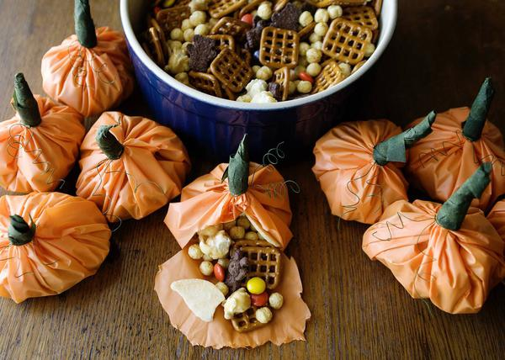

Name: ARTICLE REVIEW

Title: ________________________________________________________________________________
Information:_____________________________________________________________________________________________________________________________________________________________________________________________________________________________________________________
Thesis of the article:____________________________________________________________________
_____________________________________________________________________________________
_______________________________________________________________________________________________________________________________________________________________________________________________________________________________________________________________
Main points made to support thesis: ________________________________________________________
_____________________________________________________________________________________
__________________________________________________________________________________________________________________________________________________________________________ ____________________________________________________________________________________________________________________________________________________________________________________________________________________________________________________________________________________________________________________________________________________
_____________________________________________________________________________________
Other information of interest:_____________________________________________________________
_____________________________________________________________________________________
__________________________________________________________________________________________________________________________________________________________________________ ____________________________________________________________________________________________________________________________________________________________________________________________________________________________________________________________________________________________________________________________________________________
Personal response:______________________________________________________________________
_____________________________________________________________________________________
_______________________________________________________________________________________________________________________________________________________________________________________________________________________________________________________________

