Immigration OPTIC

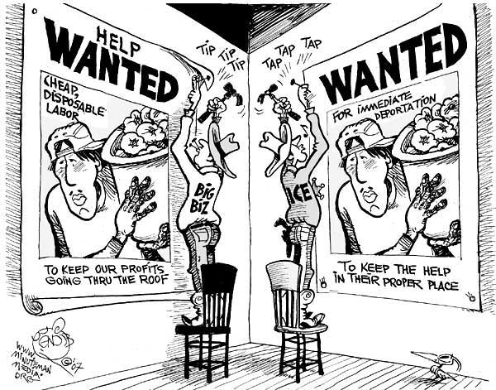

Object | O
Parts | P
Title  Words | T
Inferences | I
Conclusion | C

