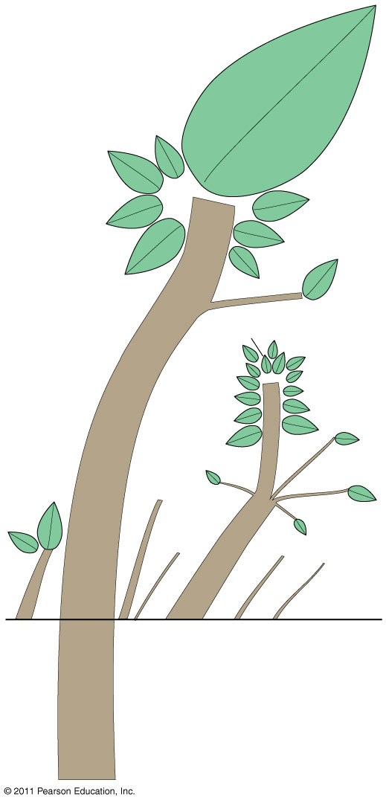
Name: Date: Per:
LANGUAGE FAMILY TREE – Language families are divided into branches and groups. Shown here are language families and individual languages that have more than 5 million speakers. Numbers on the tree are in millions of speakers. Below ground level, the language tree’s “roots” are shown. However, the theory that several language families had common origins tens of thousands of years ago is a highly controversial speculation advocated by some linguists and rejected by others. Label all the languages on the tree. Page 154-55.

