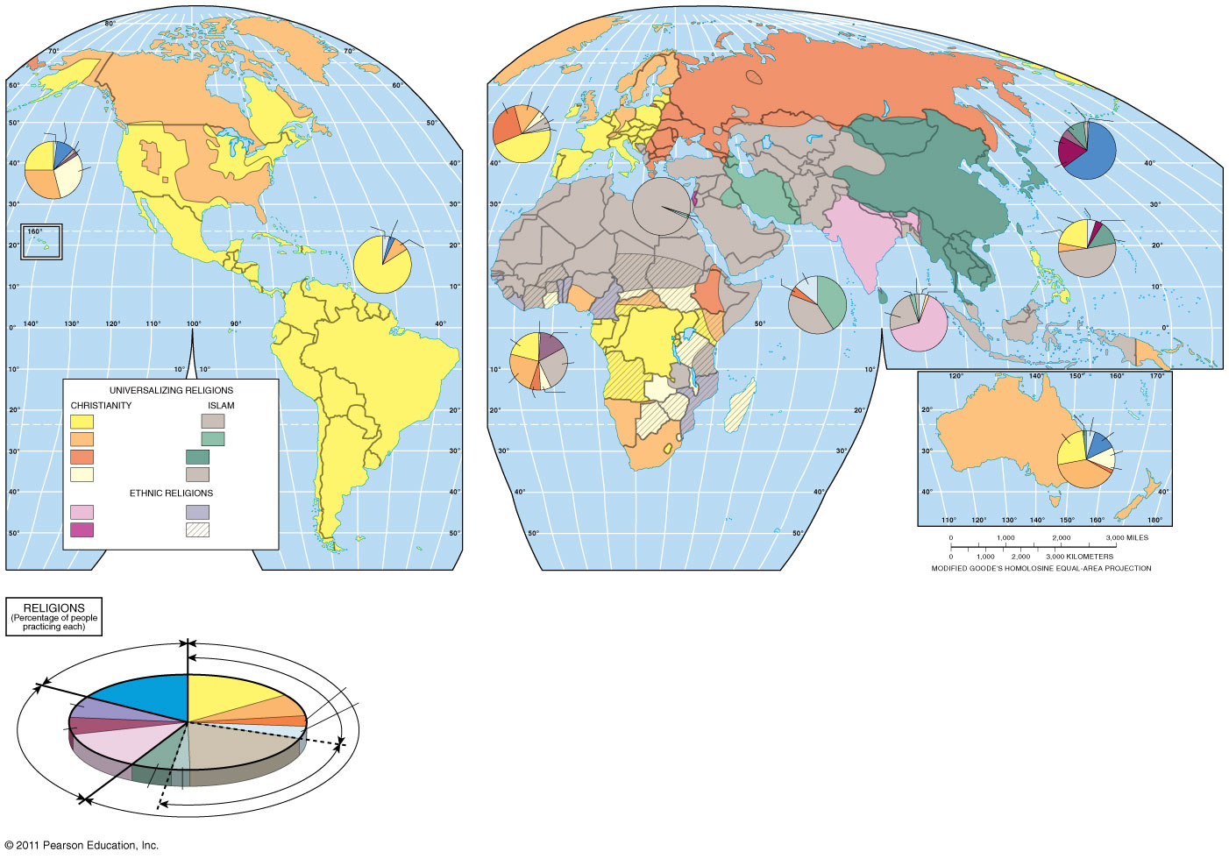
Name: Date: Per:
Religion Map

;

