Top 10 Most Developed Countries in the World
Article by Maruthappan, June 9, 2013

We do all know that developed nation is a country which has highly developed economy and advancement in most of the scientific fields. The development of a nation is measured by a scale known as Human Development Index. It was developed by United Nations Development Program which is a wing of United Nations. And this is formulated by our Indian economist Amartya Sen and Pakistani economist Mahbu Ul Huh. It compares various aspects such as standard of living, percentage of literate people, life expectancy and quality of life. If we have to explain HDI in terms of economic terms, then it could be defined as the relation between the Gross Domestic Product, Per Capita Income and level of Industrialization.
Based on this index, countries will be classified as: Very High Human Development, High Human Development, Medium Human Development and Low Human Development. Every year Human Development Index would be calculated (expect the year of 2012). They would be compared with the previous year index. It shows the development of the country. Currently this method of calculation is criticized by many economists. As per their view, this is a more vague and inaccurate method. If I am going to come up with my own way of calculation and rank index, it would be inappropriate. Therefore I am opting for the method developed by UNDP, that is , Human Development Index. Here comes the list of top ten developed countries.
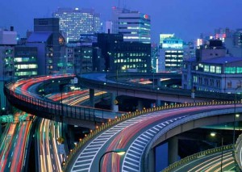
10. Japan:
Well, the list starts with an Asian country. Actually Japan has gained two positions over the last year HDI index. This is also one of the top three developed economies in the Asian region. We do all that this is the ‘third largest economy’ in terms of GDP. In the year of 2010, it lost its number 2nd position to China. This growth is attributed to their advancements in the infrastructure and technology field. Hydro power, Industrial Robotics, Chemical, Automobile and Machinery. These are few of the fields in which this Island Nation leads the world through their advancement in technology. To mention about their infrastructure, they do make use of natural gas, water and nuclear power to generate the electricity required. They had also established themselves as one of the nations with high life expectancy and low morality rate. Their HDI index is 0.912
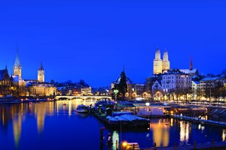
9. Switzerland:
Switzerland is one of the richest nations of the world with having highest wealth per adult. Its cities Geneva and Zurich has been ranked as the 2nd and 8th highest quality of life in the world. This also has the highest ‘Economic Freedom Index’ among other European nations. Though Switzerland is not much technologically advanced as compared to Japan, it leads Japan in terms of Highly Developed status. The reason behind this could be their development in trade, tourism, industry and agriculture. This country is one of the most stable economies. It is attributed to their political stability. Because of this they are able to attract large number of foreign investors. Their HDI index is 0.913
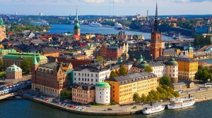
8. Sweden:
Country which borders between Norway and Finland is one of most developed countries in the world. Millions of tourists visit this country year after year. This is because since ancient times, Sweden has preferred peace over war. It is one of the countries which believe in environmental friendliness and ‘Go Green’ is one of the most famous policies formulated by the Sweden government. Its growth is attributed to the factors such as trade, industry and agriculture. Sweden’s economy is the 8th largest exporter among all the countries of the world. It is the home for 20 largest companies of the world such as Volvo, Ericsson, Sony Ericsson mobile communications and Electrolux. Recent survey showed that this country ranked the highest in telephone and internet connections. The HDI index is 0.916

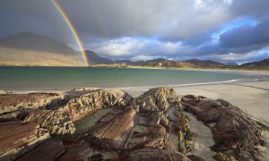
7. Ireland:
Country with the least population, say nearly 4.5 million people, is on the rapid developing phase. Nearly 99% of the people are educated and their life expectancy is 79 years. All these things made multinational companies to invest in Ireland. That is the major reason for the development of Ireland. In the early 1990’s there was a great change in consumer spending and construction & infrastructure. This period is known as Celtic Tiger period. The growth gradually increased till the year of 2007. Then it changed its direction. Hence Ireland entered in a period of recession. It exited from the same in 2010 by borrowing money from International Monetary Fund nearly € 85 Billion. Their HDI index as given by UNDP is 0.916

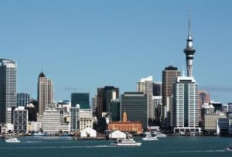
6. New Zealand:
New Zealand is a group of some remote islands. Life expectancy for an average citizen is 80.9 years. It is a great tourist destination. Since it contains a beautiful landscape and flourishing flora& fauna, it attracts flocks of tourists every year. Besides tourism, industries and trade also contributed to the growth of New Zealand. Various products such as gold, kauri gum, timber products were manufactured and exported. Nation suffered from higher economic depression during 1981 and 1982 due to the Oil crisis and Energy crisis. Then several governments engaged with various economic reforms, known as Regronomics, and brought back situation to control by 1984. From then this island country grow slowly and steadily. Their HDI index is 0.919.

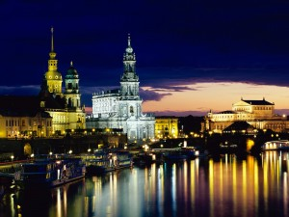
5. Germany:
Country having the largest population among the European countries (83 million) holds the position 3 in the Highly Developed status among its European counterparts. The literacy rate among the representative of the government is 99% (stunning!). We do all know that Germans are known for their high skilled force and low level of corruption. Germany serves as the headquarters of many Multinational companies like Volkswagon, Daimler, Siemens and BMW. This is one of the hot tourist spot destinations and they are known for their marvelous buildings, inner architecture, and rich bio diversity. Their HDI index is 0.920. In the previous index, they stood at 8th rank and now they accelerated to this position.
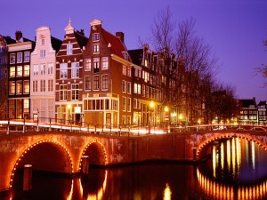
4. Netherlands:
This is the second highly developed European economy. The people of Netherlands have been reported as the happiest people in the world having low taxes, less corruption, high education standards and good health care facilities. Like many other developed countries, they do offer good support for the growth of industries. Some of the leading sectors of this country’s economy are shipping, banking, trade and fishing. Electrical, chemical, machinery and metallurgy industries flourished here. Some of them are Unilever, Philips, ING and Heineken. Their HDI index is 0.921. Last year they stood at 3rd position and now they have descended in to 4th position.

3. United States:
Literally this is the Capital of the world. The famous proverb “When America sneeze, whole world catches cold” was proved again by the year of 2008. As America is spiraled down by massive debts, the exports of whole world reached its new down level and it resulted in global recession. It is reported that life expectancy of Americans are considerably lowering due to obesity. Nearly one third of the children in U.S. suffer from obesity. Despite all this, still it rocks. Yes, I am right. The cultural diversity rating of the country is one of the highest in the world. They do have the trading alliance with almost every country in the world. They are the hub of automobile, chemical, food and beverages industry. Their HDI index is 0.937 and by the last year they stood at number 4 position.
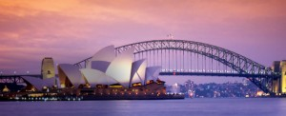
2. Australia:
Australia is ranked Number 1 in many factors (considered for HDI index) such as literacy rate, low corruption level, high quality of life, economic freedom and civil rights. The most stable government is offered to the people of Australia and this also makes them one of the happiest individuals in the world. This is one of the countries with high per capita income and low level of poverty. Three cities of Australia featured in the top 10 list of world’s most livable cities. Their HDI index is 0.938 and by the last year they were at the same level.

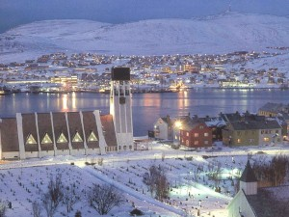
Number ONE is Norway:
Norway is the highly developed country among all the countries of the world. The government of Norway serves its people with higher level of education, lower corruption level, lower unemployment rate, higher standard of living and higher life expectancy (about 80.3 years). A question arises by what means this is possible? One should remember that Norway has one of the largest natural resources such as petroleum, seafood, natural gas and metallic ores. Banking, Metallic production and Foods & Beverages are few of the sectors which flourished well in Norway. Their HDI index is 0.955 and they are maintaining their Rank 1 for the past 9 years.

