Where children sleep: pictures from around the world
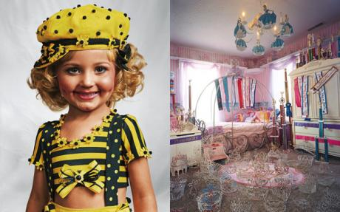
James Mollison’s photographs of children’s bedrooms, taken in locations from rubbish dumps in Cambodia to grand houses in Kentucky, present a stark lesson in inequality.

By James Mollison
7:00AM BST 18 Oct 2010

Where children sleep - in pictures
The bedroom of my childhood memories is a small room with sloping eaves in the attic of the family home in Oxford. It was first decorated with wooden animals and a teddy bear made by Mum, but I progressively made the room my own, its changing contents reflecting my interests and aspirations.

Important characters in its history included some Action Man figures I bought in a jumble sale, a Batman car and Mumsie and Diddle-Dash, two mice for whom I built a multistorey play area from wooden fruit boxes. Aged nine, I was given responsibility for choosing a new carpet.

I chose one in bright-red nylon with black-and-white stripes, which I found embarrassing as a style-conscious teenager. At 10 I used the pages of Smash Hits magazine to decorate the room, one wall dedicated to Duran Duran and another to Madonna. These were replaced with army posters, then surfer posters, then Jimi Hendrix and the Rolling Stones.

When, in 2004, Fabrica (Benetton’s creative research centre) asked me to come up with an idea for engaging with children’s rights, I found myself thinking about my bedroom: how significant it was during my childhood, and how it reflected who I was. It occurred to me that a way to address some of the complex issues affecting children would be to look at the bedrooms of children in all kinds of circumstances.
The project became a vehicle to think about poverty and wealth, about the relationship of children to their possessions, and the power of children – or lack of it – to make decisions about their lives. I travelled where I could, and many of the pictures result from chance encounters. I hope these images help other children to think about inequality around the world, and perhaps start to figure out how they may respond.

